**MEMORY CONCERNS? YOU’RE NOT ALONE.**

**FREE CONFIDENTAL MEMORY SCREENINGS**

**National Memory Screening Program is an initiative of:**

**Alzheimer’s Foundation of America**

**www.alzfdn.org | 866-232-8484**

AFA’S National Memory Screening Program is made possible with a grant from Edward N. and Della L. Thome Memorial Foundation, Bank of America, N.S.Trustee

**Each memory screening takes approximately 10 minutes and while the result is not a diagnosis, it can suggest if someone should see a physician for a full evaluation.**

Location: Your Screening Location

Date: Your Screening Date

Time: Your Screening Time

Phone: Your Organization’s Phone Number

A MEMORY SCREENING IS A SIMPLE AND SAFE “HEALTHY BRAIN CHECK-UP”

THAT TESTS MEMORY AND OTHER THINKING SKILLS.

**YOU CAN A MEMORY SCREENING AT THE LOCATION BELOW:**

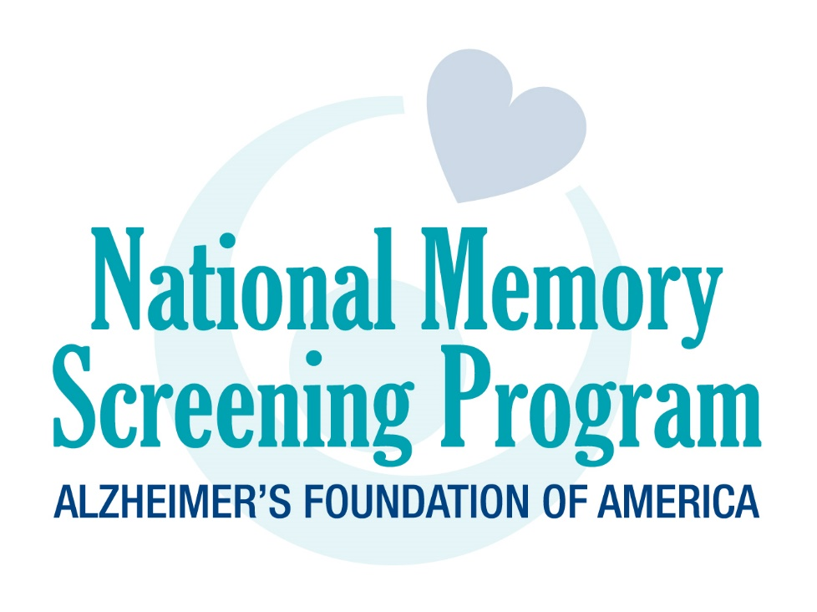

*Insert your*

*Organization’s   
logo here*